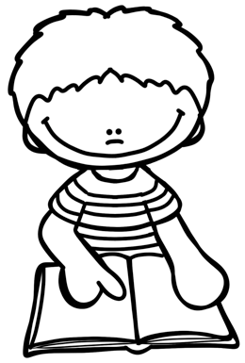
Kindergarten
Sight Words

Below is the list of 75 kindergarten sight words. Please work on the sight words at home with your child. All kindergarten students in Manhattan Beach need to know all 75 words before the end of the school year. Make it fun! The more they practice, the quicker they will learn the words! They may even be able to sing some of the words to you.

- no
- is
- can
- me
- you
- and
- he
- at
- a
- so
- on
- in
- up
- am
- we
- like
- see
- I
- go
- it
- do
- an
- the
- my
- to
- yes
- come
- are
- mom
- went
- play
- for
- saw
- they
- she
- look
- was
- his
- run
- put
- sat
- all
- by
- her
- too
- will
- not
- as
- be
- eat
- get
- had
- of
- ran
- how
- ball
- us
- man
- or
- boy
- now
- girl
- if
- him
- sit
- this
- did
- out
- then
- got
- day
- has
- say
- jump
- read

If your child has already mastered this list, you can work on helping them spell the words. You can also begin to work on the next set of first grade words.

Thank you!
